**CHAPTER 1**

* 1. **PROJECT INTRODUCTION**

The project is designed to operate electrical loads using a TV remote. The remote transmits coded infrared data which is then received by a sensor interfaced to the control unit. The system operates electrical loads depending on the data transmitted from the TV remote. Operating conventional wall switches is difficult for elderly or physically handicapped people. This proposed system solves the problem by integrating house hold appliances to a control unit that can be operated by a TV remote. NEC based coded data sent from the TV remote is received by an IR receiver interfaced to the microcontroller of 8051 family. The program on the microcontroller refers to the NEC code to generate respective output based on the input data to operate a set of relays through a relay driver IC. The loads are interfaced to the control unit through the relays.

The system can be used in existing domestic area for either operating the loads through conventional switches or with the tv remote. The project can be enhanced by using radio frequency technology where the operational range shall be independent of line-of-sight distance as often encountered with IR type of remote control.

**CHAPTER 2**

**2.1 COMPONENT LIST**

* Power Supply
* Micro Controller

**2.1.1 POWER SUPPLY**

* Diode
* Capacitor
* Transformer
* Bridge Rectifier
* Regulator

**DIODES:**

A PN Junction Diode is one of the simplest semiconductor devices around, and which has the characteristic of passing current in only one direction only. However, unlike a resistor, a diode does not behave linearly with respect to the applied voltage as the diode has an exponential current-voltage (I-V) relationship and therefore we cannot describe its operation by simply using an equation such as Ohm’s law.

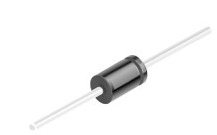

**Fig 2.1 Diode**

**CAPACITOR:**

A capacitor is a passive electronic component that stores energy in the form of an electrostatic field. In its simplest form, a capacitor consists of two conducting plates separated by an insulating material called the dielectric. The capacitance is directly proportional to the surface areas of the plates, and is inversely proportional to the separation between the plates. Capacitance also depends on the dielectric constant of the substance separating the plates.

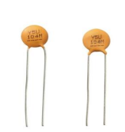 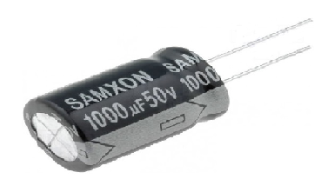

**Fig 2.2 Capacitor**

**TRANSFORMER:**

A transformer uses the principles of electromagnetism to change one A.C. voltage level to another. Faraday's work in the 19th century showed that a changing current in a conductor (e.g., a transformer primary winding) sets up a changing magnetic field around the conductor. If another conductor (secondary winding) is placed within this changing magnetic field a voltage will be induced into that winding.

A transformer is a static electrical device that transfers electrical energy between two or more circuits. A varying current in one coil of the transformer produces a varying magnetic flux, which, in turn, induces a varying electromotive force across a second coil wound around the same core. Electrical energy can be transferred between the two coils, without a metallic connection between the two circuits.

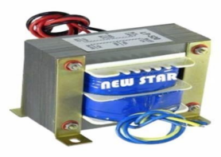

**Fig 2.3 Transformer**

**BRIDGE RECTIFIER:**

A diode bridge is an arrangement of four diodes in a bridge circuit configuration that provides the same polarity of output for either polarity of input. It is used in most common application, for conversion of an alternating current input into a direct current output, it is known as bridge rectifier. A bridge rectifier provides full-wave rectification from a two-wire AC input, resulting in lower cost and weight as compared to a rectifier with a 3-wire input from a transformer with a center-tapped secondary winding.

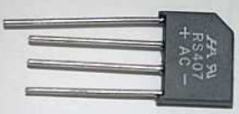

**Fig 2.4 Bridge Rectifier**

**REGULATOR:**

Voltage sources in a circuit may have fluctuations resulting in not providing fixed voltage outputs. The internal current-limiting and thermal-shutdown features of these regulators essentially make them immune to overload. A voltage regulator IC maintains the output voltage at a constant value. 7805 IC, a member of 78xx series of fixed linear voltage regulators used to maintain such fluctuations, is a popular voltage regulator integrated circuit (IC). The xx in 78xx indicates the output voltage it provides. 7805 IC provides +5 volts regulated power supply with provisions to add a heat sink.

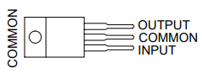 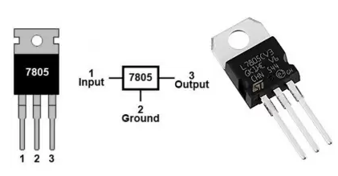

**FIG 2.5 7805 PINOUT DIAGRAM**

**2.2 AT89C51 MICROCONTROLLER**

**2.2.1 INTRODUCTION**

Microcontroller is a general-purpose device, which integrates a number of the components of a microprocessor system on to single chip. It has inbuilt CPU, memory and peripherals to make it as a mini computer. A microcontroller combines on to the same microchip they are CPU core, Memory (both ROM and RAM), Some parallel digital I/o. Microcontrollers are small in size, inexpensive, consumes less power.

Micro controller is a standalone unit, which can perform functions on its own without any requirement for additional hardware like I/O ports and external memory. The heart of the microcontroller is the CPU core. In the past, this has traditionally been based on an 8-bit microprocessor unit. For example, Motorola uses a basic 6800 microprocessor core in their 6805/6808 microcontroller devices.

AT89C51 is the 40 pins, 8-bit Microcontroller. It is the flash type reprogrammable memory. Advantage of this flash memory is we can erase the program with in few minutes. It has 4kb on chip ROM and 128 bytes internal RAM and 32 I/O pin as arranged as port 0 to port 3 each has 8-bit bin. Port 0 contain 8 data line(D0-D7) as well as low order address line (AO-A7).

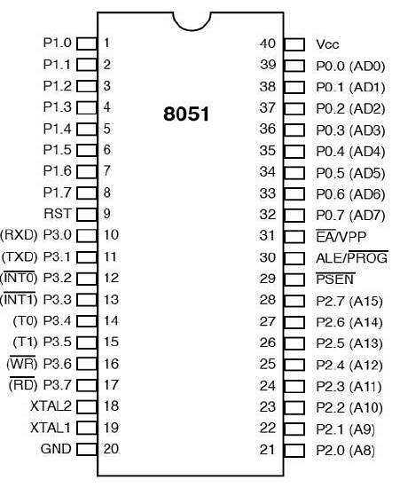

**Fig 2.6 Pin diagram of 8051 microcontroller**

Port 2 contain higher order address line (A8-A15). Port 3 contains special purpose register such as serial input receiver register SBUF, interrupt INT0, INT1 and timers T0, T1 many of the pins have multi functions which can be used as general purpose I/O pins (or) Special purpose function can be decided by the programmer itself.

**2.2.2 FEATURES**

* 4KB bytes on-chip program memory (ROM).
* 128 bytes on-chip data memory (RAM).
* Two 16-Bit Timer/Counters.
* 8-bit bidirectional data bus.
* 6-bit unidirectional address bus.

The AT89C51 is a low-power, high-performance CMOS 8-bit microcomputer with 4K bytes of Flash Programmable and Erasable Read Only Memory (PEROM). The device is manufactured using Atmel is high density non-volatile memory technology and is compatible with the industry standard MCS-51™ instruction set and pinout.

**2.2.3 I**/**O PORTS**

**Thirty - two Input / Output pins:**

All four ports in the 8051 are bi-directional each contains a latch, an output driver and input buffer. The output drivers of port0 and 2, and the input buffers of port 0 are used in access to external memory. In this application port 0 is used as a lower byte of the external memory address multiplexed with data bus and port 2 is used as a higher byte of the external memory address when address is sixteen bits wide. Otherwise, it can be used as general purpose I/O

**P0(PORT0):**

The P0 (zero) port is characterized by two functions −When the external memory is used then the lower address byte (addresses A0A7) is applied on it, else all bits of this port are configured as input/output. When P0 port is configured as an output then other ports consisting of pins with built-in pull-up resistor connected by its end to 5V power supply, the pins of this port have this resistor left out.

**P1(PORT1):**

P1 is a true I/O port as it doesn’t have any alternative functions as in P0, but this port can be configured as general I/O only. It has a built-in pull-up resistor and is completely compatible with TTL circuits.

**P2(PORT2):**

P2 is similar to P0 when the external memory is used. Pins of this port occupy addresses intended for the external memory chip. This port can be used for higher address byte with addresses A8-A15. When no memory is added then this port can be used as a general input/output port similar to Port 1.

**P3(PORT3):**

In this port, functions are similar to other ports except that the logic 1 must be applied to appropriate bit of the P3 register.

**2.2.4 APPLICATIONS**

* Light sensing and controlling devices.
* Temperature sensing and controlling devices.
* Fire detections and safety devices.
* Automobile applications.
* Process control devices.
* Defense applications.
* Voltmeter applications.
* Remote Control Home Appliances.
* Voice Controlled Home Appliances.